1. Create aws.amazon.com account first
2. Then login into AWS console
3. 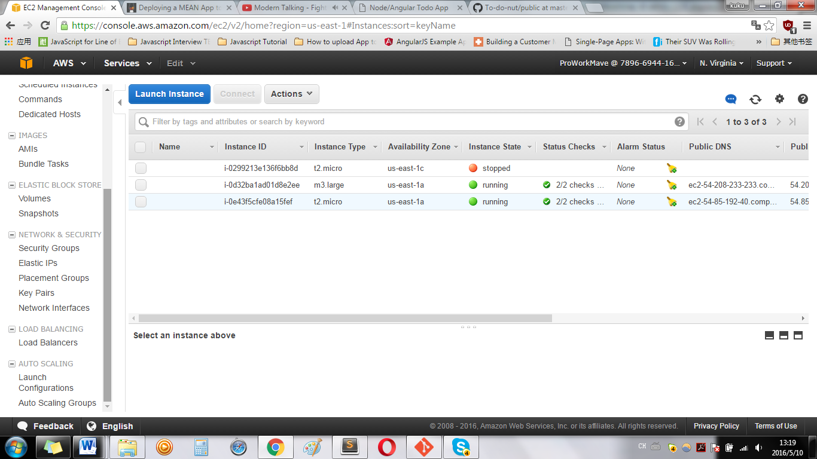
4. Before creating EC2 instance, create key pair on the left pane, key pair is required for accessing instance for each instance
5. Press key pair on the left pane , then press Create Key Pair( name something for easy memorizing, such as your-user-name-key-pair etc).
6. After key pair created, download key pair file . pem, save to a safe folder for later usage.
7. 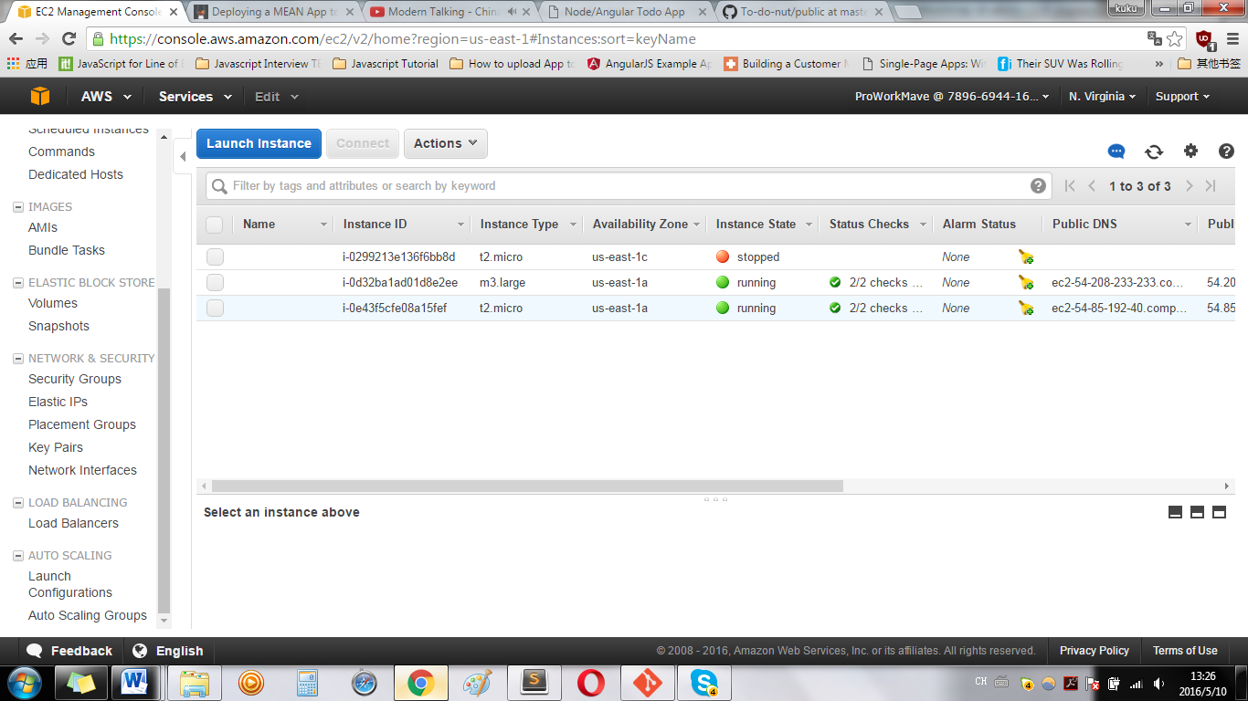
8. Press Launch Instance
9. 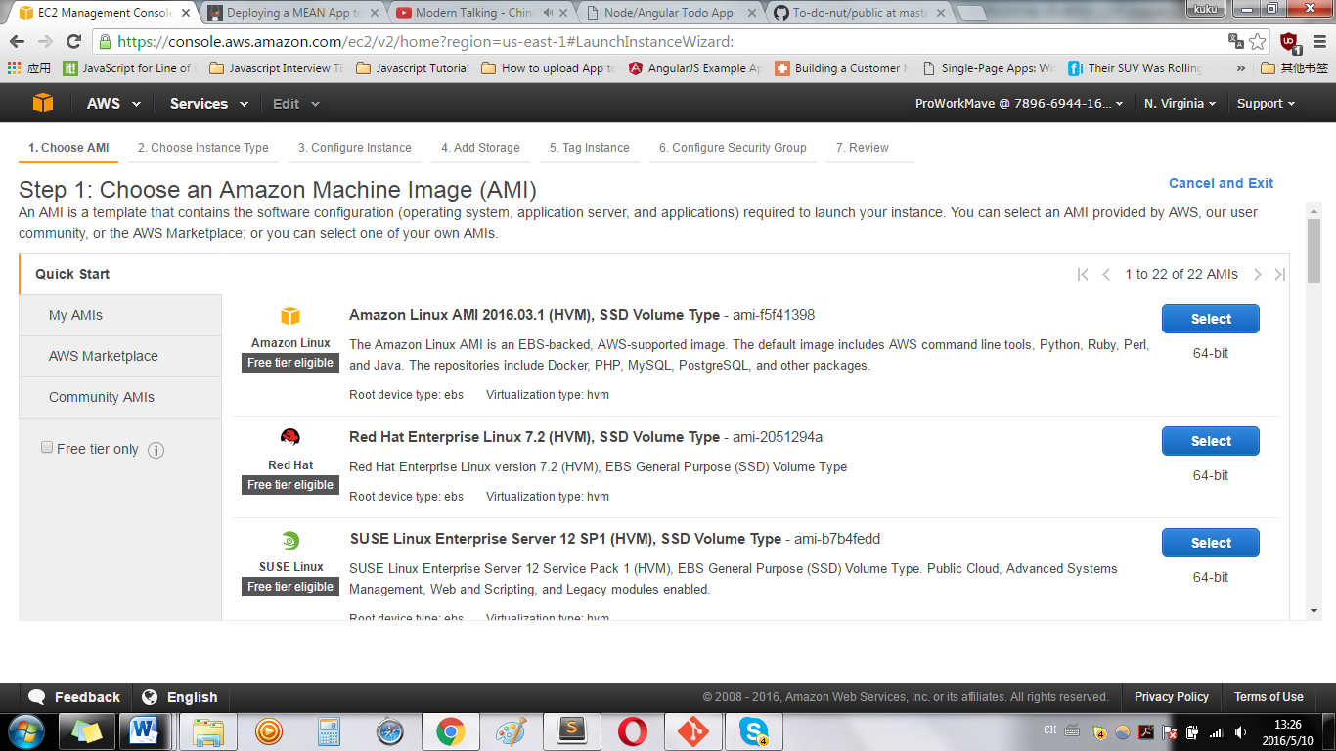
10. 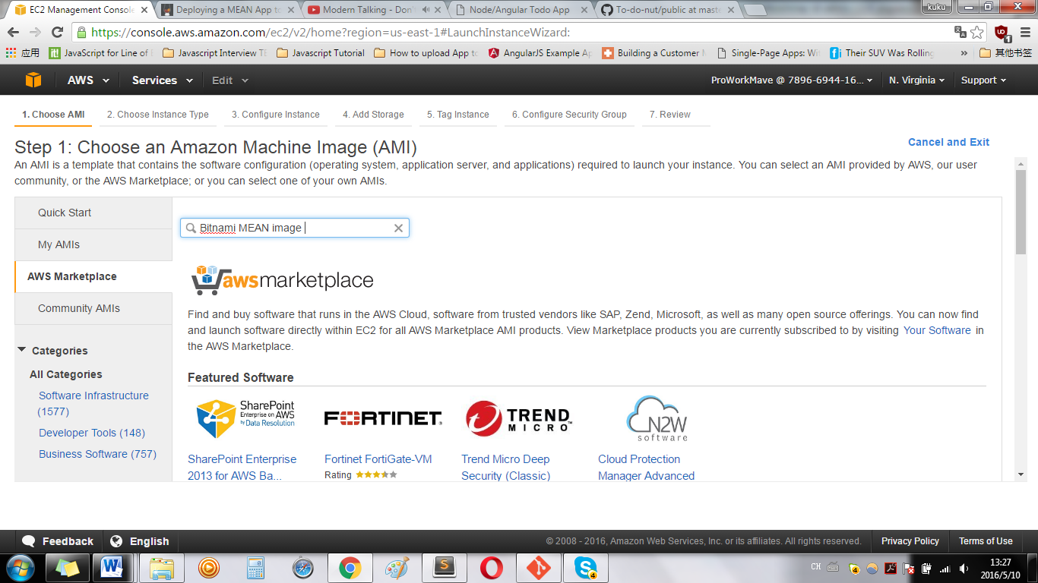

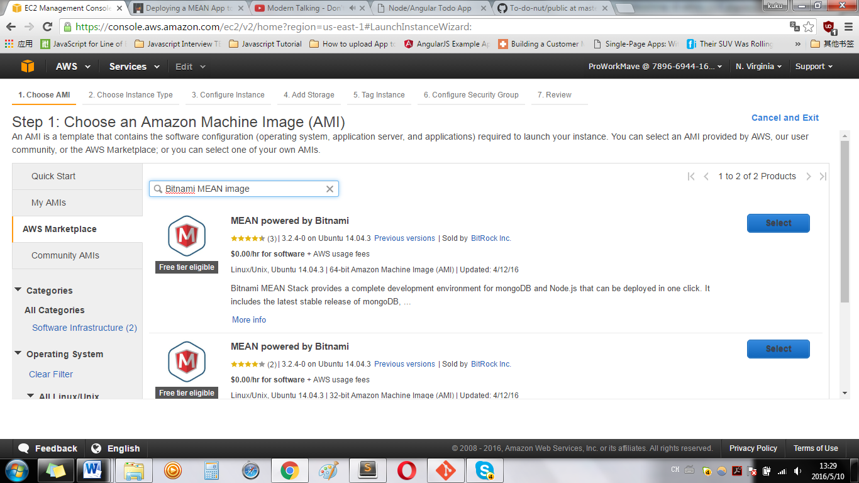

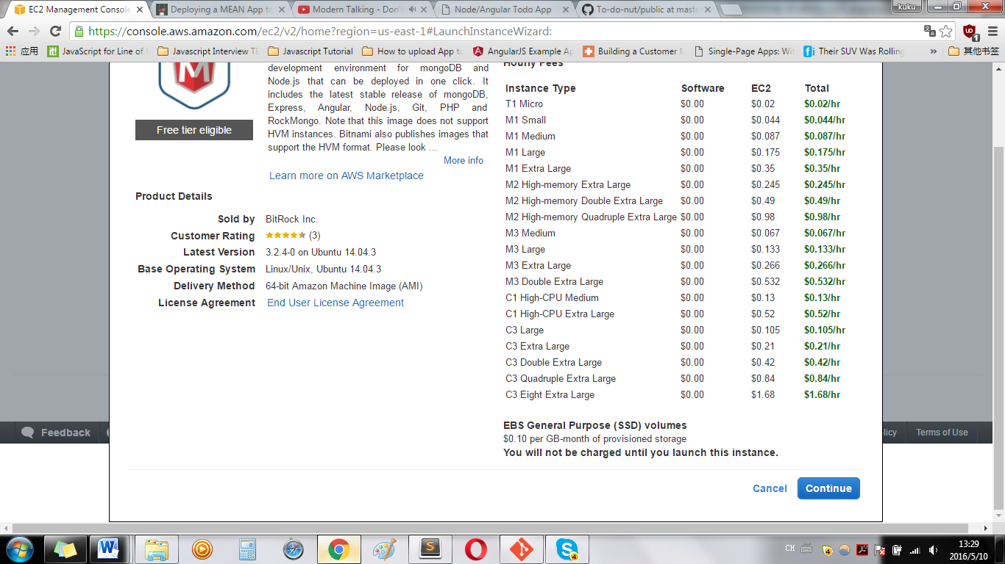

Press Continue

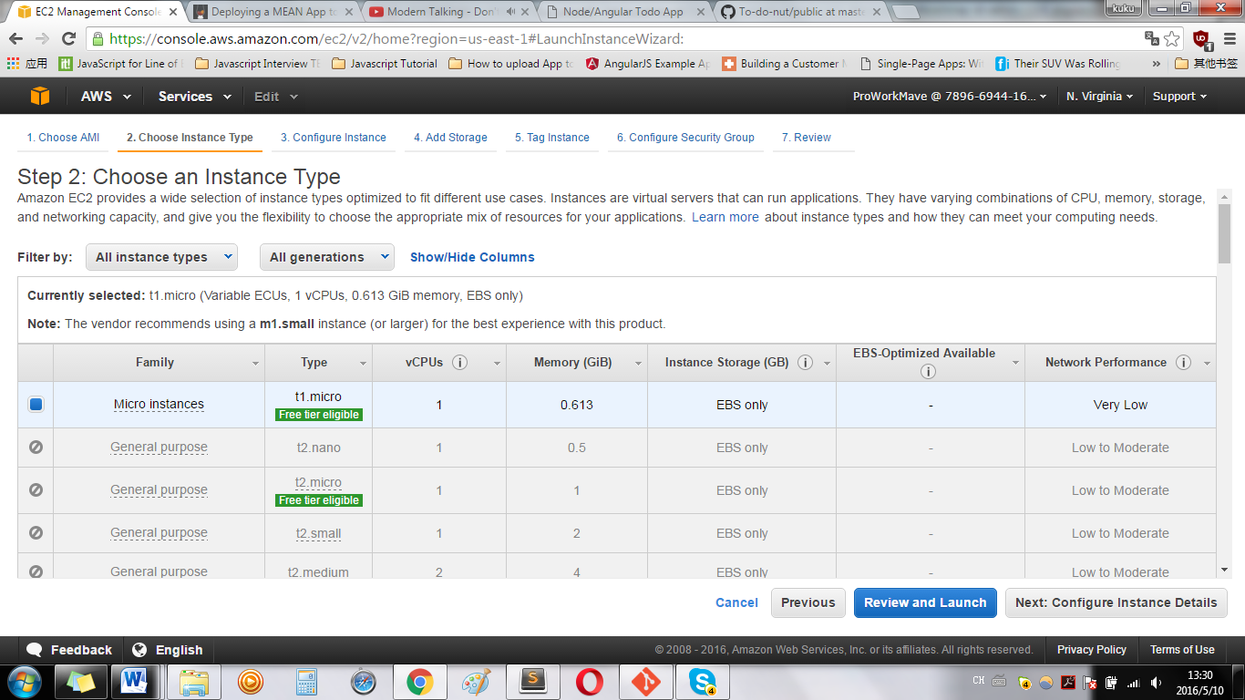

Optional: press Next: Configure instance Details

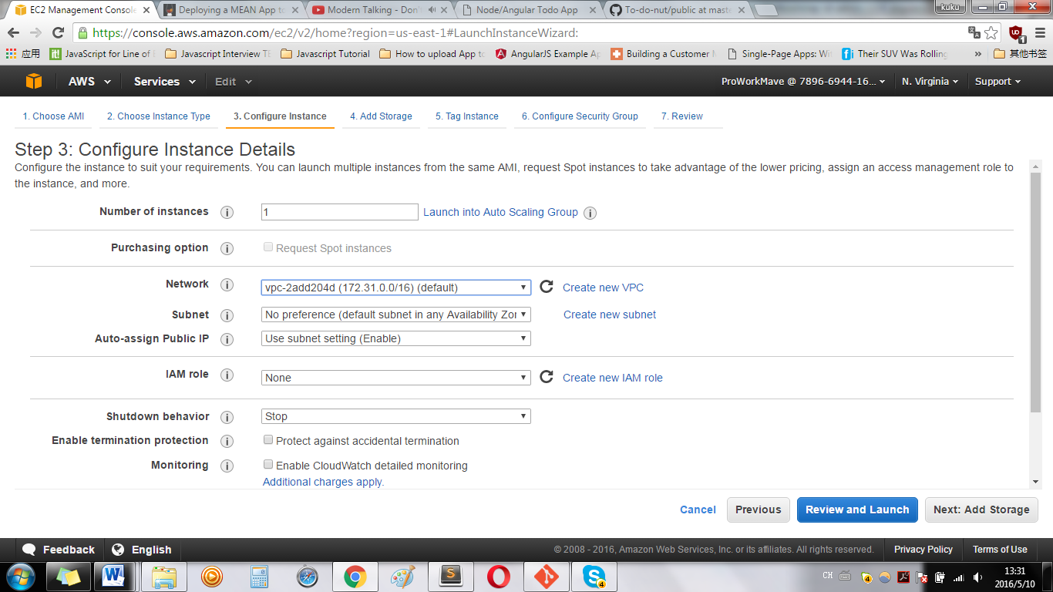

Optional: keep default

Press Review and Launch

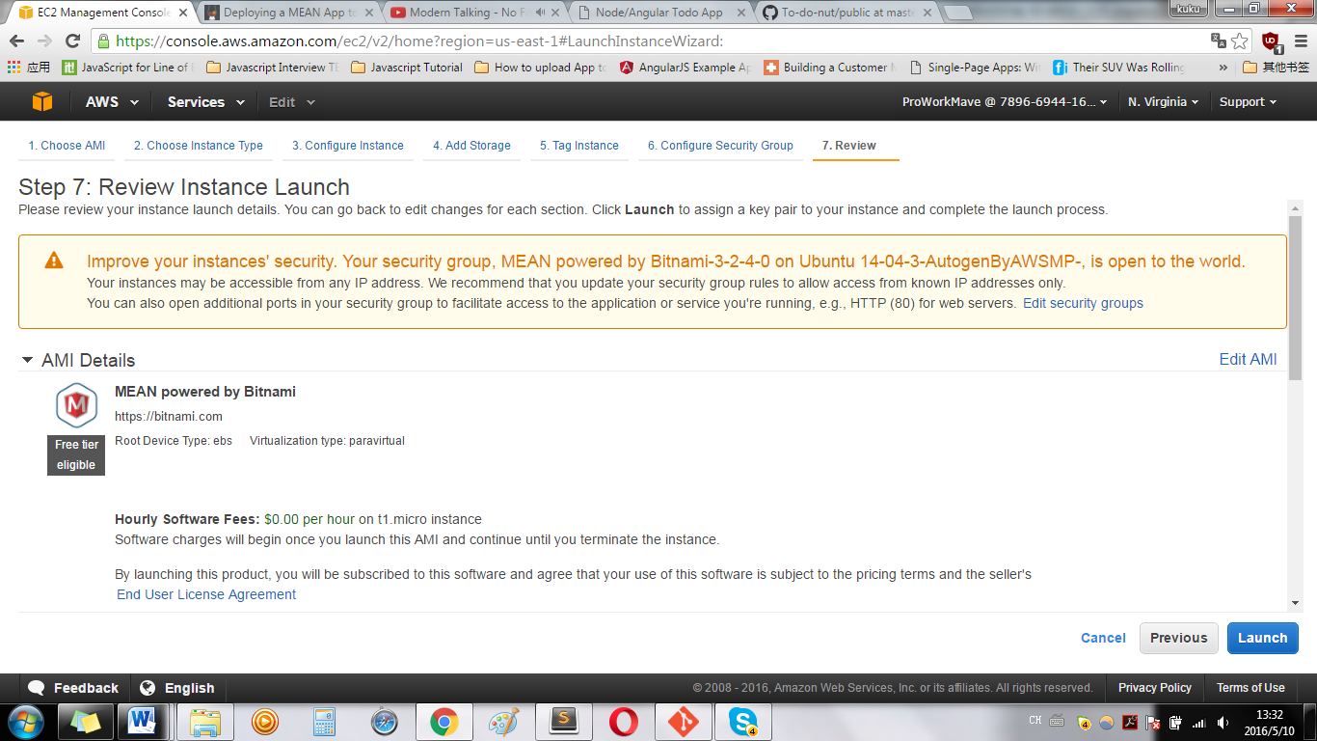

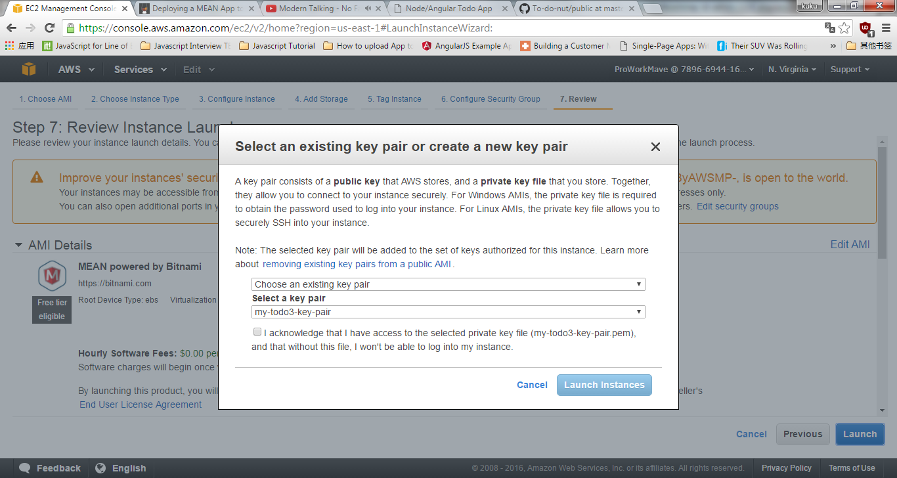

Everything is all right till now, check the check box, and press Launch instance

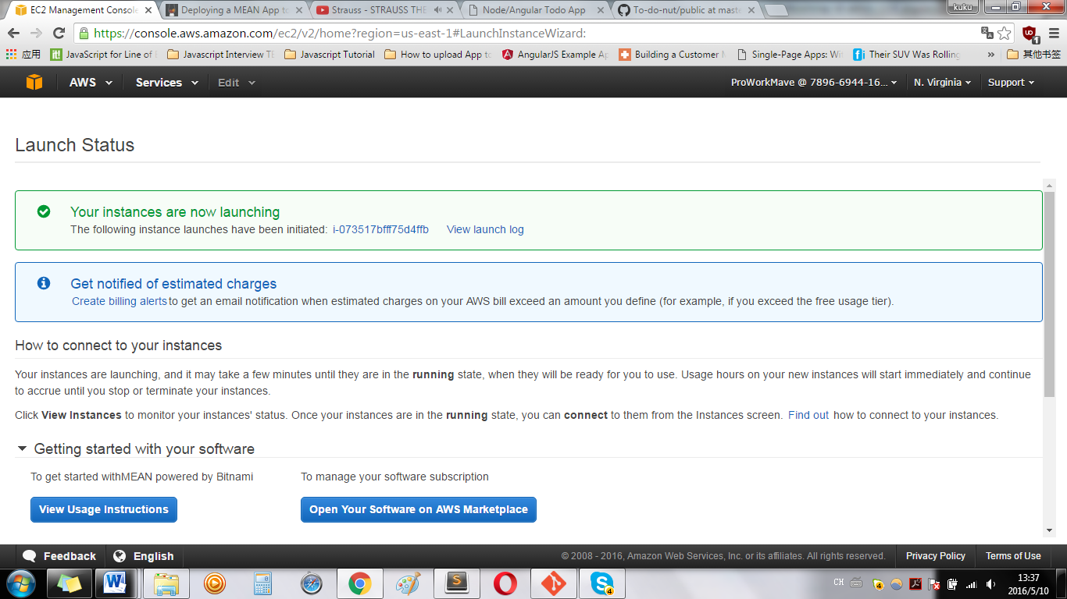

**3.2.4-0 on Ubuntu 14.04.3 Usage instructions for MEAN powered by Bitnami**

Once the instance is running, you can connect to it using your Amazon private key and the username 'bitnami' via SSH. You can find all the Stack components like Apache, MongoDB, etc and the required dependencies in the '/opt/bitnami' folder. Please check our documentation at <https://bitnami.com/aws-credentials> to learn how to get your password.

Upload code –your project folder and files to this server

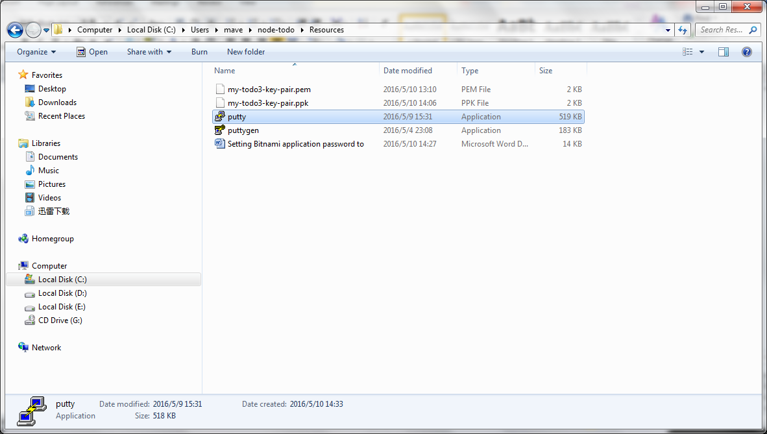From the above screen, (from your project folder), open puttygen,

Press right down button of the pop up window “Load key”, browse to select *****-key-pair.pem, ( choose All files, only this way you can see the .pem file name)

* Press Save Private Key, ( choose all files), save . pem file to .ppk file.
* Open putty

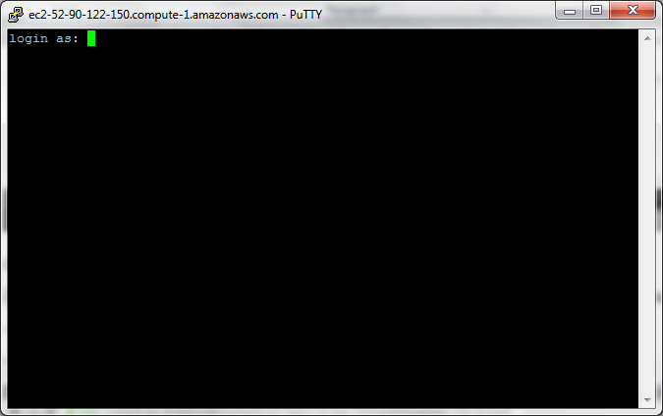

Before the above screen, there is a Warning pop up window, just press Yes.

* Copy and paste Public DSN to Host name in putty window ( click your EC2 instance, see the description tag, …. You’ll find it)
* On the left pane , scroll down to find SSH/Auth, click Auth then you see: Authenation…. Browse to choose –key-pair.ppk file, then press Open
* 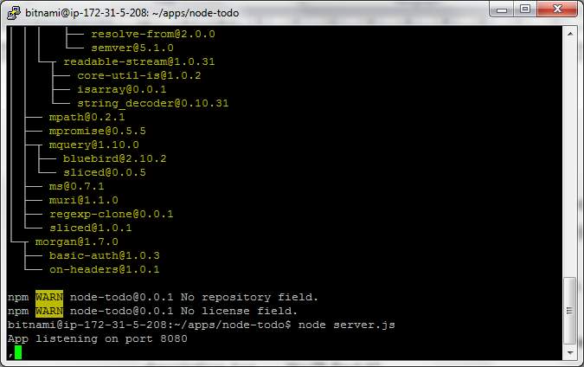
* Login as: bitnami
* Then: sudo git clone https:------------\node-todo.git. **-your github link to pull down to your project folder
* Then : cd node-todo
* Then: run: $node-todo: sudo npm install
* Then: $node-todo: node server.js
* In Putty window display: listen to port:8080
* Then: go to : open browser to type : Public DSN:8080
* NOTHING HAPPEN?

We are going to fix it:

Go back to aws console , click running EC2 instance,

Then choose Security Group from the left pane,

Cho

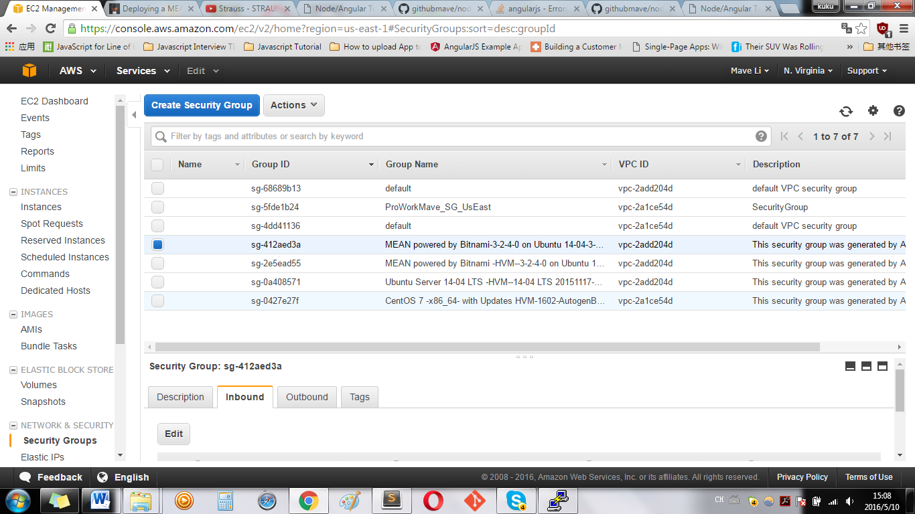

Choose a Security Group and click inbound

(Editing Security Group must be implemented after EC2 instance has been launched.)

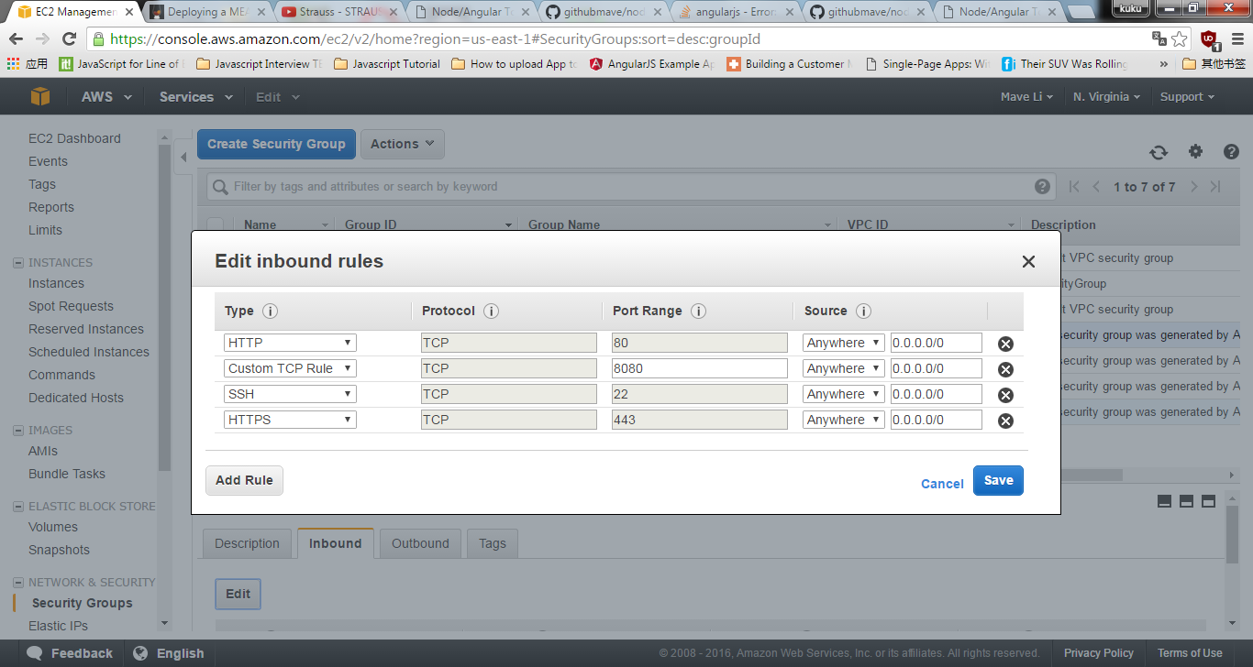

Click Add Rule, make sure: add Custon TCP Rule-----Port Range: 8080, Source:anywhere,0.0.0.0

Click Save

Then come back putty window,

And $node-todo: node server.js

Browse the address: Public DSN:8080,

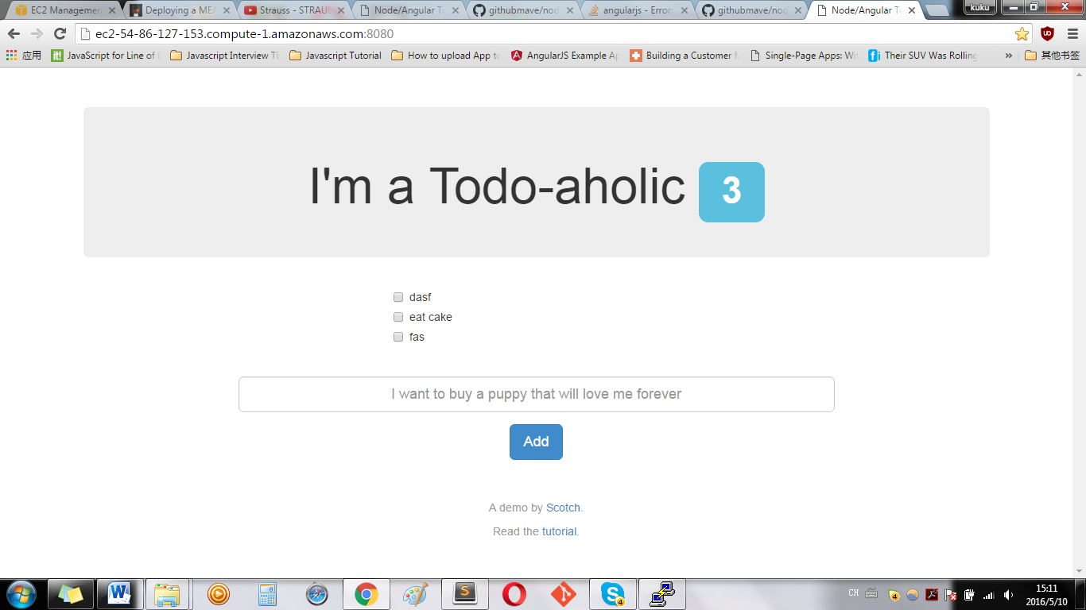

DONE!

(Notice: if putty’s log reply with error, then EC2 instance you has just created died straight away.

But when you close putty client, the server will die too.

How can you fix it?

So instead, we’re going to utilize the node package [forever.js](https://github.com/foreverjs/forever). Forever is a simple tool that ensures a given script runs continuously (i.e. forever). To install it, let’s first stop our existing application with ctrl+c.

Then we’ll run:

sudo npm install forever -g

And finally, to launch our application continuously, we wil enter

forever start server.js

in putty window, won’t show” listen on port 8080”, you just browse the host is OK